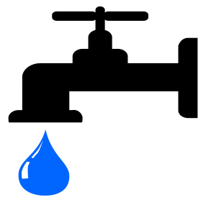
Name: _________ Water Use! Date: ________

Review:

- Describe what it means to conserve water.

_____________________________________________________

- List 4 ways we can reduce water at home_____________________

______________________________________________________
We will read page 92 of the textbook to answer the following questions.
- Fill out the table below showing the different types of water: Blue water, green water and grey water.

Type of water | Definition
Blue water
Green water
Grey water

- What percentage of fresh water is used for agriculture (farming)?

__________________________________________________

- True or false? Australia has one of the highest per capita (per person) water rates in the world.
_____________________________________________________
- Examine the pie chart on page 93 (source 5.9.4) and identify the three largest areas of water use in Australian homes. Record the percentage next to your answer.

_________________________________________________________

- Do you think these would be the largest areas of use in your house? Explain your answer.

- Refer to page 93, how many litres of water does an average Australian use every day?
_________________________________________________________

- Examine the chart on page 92 (source 5.9.2). Describe what pattern you see with the amount of water being consumed in the world since 1900. For example is this increasing or decreasing?

_________________________________________________________

Extension: Read pg 96 on water footprints. Write a definition for water footprint below:

_________________________________________________________________

- Extension: if you have had your work checked by the teacher, please collect your extension work ’50 ways to save water around the home’.

